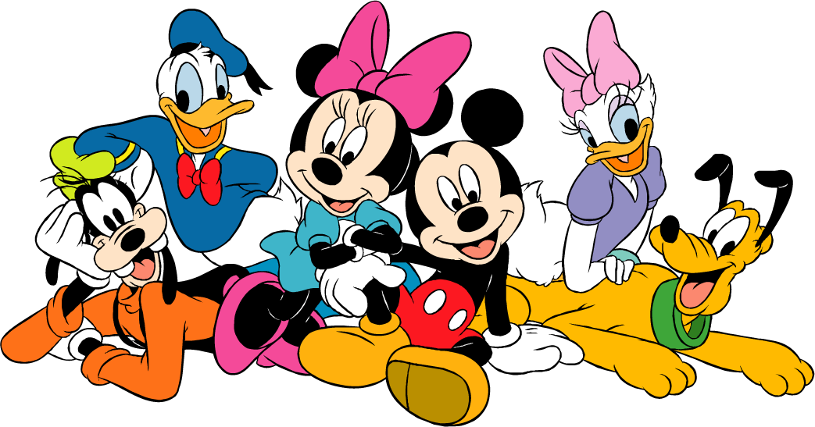
Walt Disney World Travel Tips

Planning Your Day
- When you enter the park, grab a park map and a times guide. The park map will tell you where the rides, restaurants, and restrooms are located. The times guide will tell you when to catch shows, parades, and fireworks.

- Hit popular rides early in the day, as the lines will only get longer as the day goes on. You can choose to ride these rides if the lines are short, or you may decide to pick up a FastPass (FP) for later. These rides are the most popular in each park and should be visited as soon as you get to the park:
  - Magic Kingdom: Thunder Mountain, Space Mountain, Splash Mountain
  - Epcot: Soarin’, Test Track
  - Hollywood Studios: Tower of Terror, Rock’n Roller Coaster, Toy Story Mania
- FastPasses can be used at the rides listed above, as well as several other rides. FastPasses are like a reservation to get into a ride. Stick your ticket into the machine and out pops a piece of paper with your ride time on it. While you wait for your ride, visit the shops, restaurants, or smaller rides nearby.

- FastPasses will run out, so make sure that you get them for the ride that you really want to ride as early as possible.

- At the bottom of your FastPass is the time when your next FastPass is available. You cannot go around the park and grab FastPasses for every ride at the same time. You must wait until your next available time.

- Save rides without FastPasses for later in the day. The rides without FastPasses usually do not have long lines and can be visited any time during the day.

- For shows and parades, people grab spots around 30-45 minutes ahead of time. If you want good seats, then plan to get there early.

- Eat at off times to avoid long lines at the food counters. Aim for lunch around 11:00 a.m. and dinner around 4:30 p.m. This will also allow for a late night snack like ice-cream or popcorn.

- If you do not want to watch the parades, then go hit some rides. Ride lines are usually shorter during the parades and fireworks since so many people will be watching them.
Saving Money on your Trip
- When you eat at a restaurant, ask for a cup of water instead of a bottle of water. Cups of water are FREE! Bottles are $2.50 or more, which can add up to more than $5.00 each day on water alone!

- If you do buy a water bottle, keep it! You can refill it at the water fountains throughout the day.

- Share a meal or a snack with a friend. There are lots of food choices throughout the park (burgers, fries, sandwiches, salads, chicken fingers, hotdogs, turkey legs, pasta, pizza, etc.). Check the park map for the pricing guide for each restaurant. Restaurants are listed with a dollar sign pricing per person ($ = $14.99 and under, $$ = $15.00-$35.99, etc.).
- Be a smart shopper! Magnets, key chains, pens, and pencils are all affordable souvenirs. Look for sales and lower price sections. Sometimes you might find discount racks where everything is $10.00 or less. Set a souvenir budget!
Packing for the Parks
- Bring a backpack or drawstring tote to carry your necessary items. All bags will need to be checked by security upon arrival at each park.
- Fill up a 1-quart Ziploc bag with the following items: Plastic poncho, small hand sanitizer (or hand cleaning wipes), band aids, travel tissue pack. All items can be purchased at the dollar store.
- Items to protect you from the sun (sunglasses, hats, sunscreens, etc.)
- Snacks that won’t melt (granola bars, crackers, peanuts, pretzels, fruit snacks, etc.) are a good idea. Chocolate and peanut butter are not recommended, as they will be messy!
- Don’t pack anything that is not necessary. It will only add extra weight to you all day.
- Disposable cameras are lightweight and are not a big deal if they get damaged or lost.
General Tips
- There are lots of souvenirs to buy at WDW. General souvenirs (paper and pencil sets, coffee mugs, keychains, magnets, postcards, etc.) are available at almost every store. Wait to buy them at the end of the day so that you don’t have to carry them around all day. If you want to buy something specific to a ride (Tower of Terror shirt, Space Mountain keychain, etc.), then you must buy it at the ride. It is not available anywhere else!
- Gum is not sold anywhere at WDW, so bring your own if you must have it.
- All parks have a first aid station. They can provide band aids, water, and a cool place to rest if you are not feeling well. Ask any park employee and they will tell you how to get there.
- When you are waiting in a line, use the time to look at the map and plan your next stop. This will help to keep your day moving and cut down on the amount of lost/wasted time (“Uh…where do you want to go? Uh…I don’t know?)
- Be flexible and willing to compromise with your group regarding your plans. Don’t try to call all the shots.
- Have a designated meeting place in each park for your group. If someone gets lost and cell phones are not working, you can still find each other by going to your designated meeting place. Suggested meeting places for each park are listed below or you can use Guest Relations. Each park has a Guest Relations which is the headquarters for anyone that gets lost or separated from their group, as well as lost & found items. Look for it on the map when you arrive.
- Magic Kingdom: Statue of Mickey and Walt in front of the castle
- Epcot: meet at the tip board/pin trading store right behind Spaceship Earth
- Hollywood Studios: meet in the store under the big blue Sorcerer’s Hat

